The Anatomy of Free Will

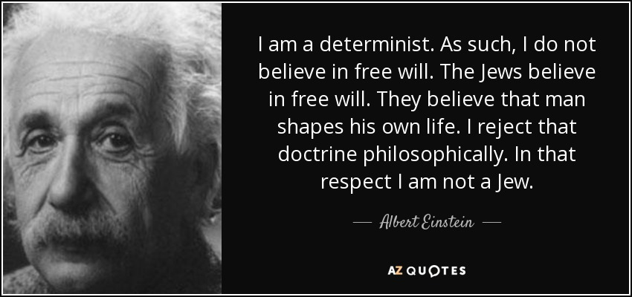

Introduction
Pirkei Avos (Ethics of the Fathers) 3:18
Beloved is man, for he was created in the image of God; it is a sign of even greater love that it has been made known to him that he was created in the image, as it is says, "For in the image of God, He made man" (Genesis 9:6).
Sforno Bereishis (Genesis) 1:26-27
Unlike all other creations, man was given free will.

Devarim (30:19)
See I have put before you, life and death, good and evil, blessing and barrenness…choose life.

Pirkei Avos (Ethics of the Fathers) 4:1
...Who is strong? One who overpowers his inclinations. As is stated (Proverbs 16:32), "Better one who is slow to anger than one with might, one who rules his spirit than the captor of a city..."

#1 CASE:
A wealthy woman is arrested for the tenth time stealing candy from a store. She knows it’s wrong, she hates herself for it, but she feels an extraordinary pleasure when she steals candy, and although she wishes she could stop, she doesn’t.

Question:
You are the judge. What sentence would you give?

First let’s hear what the Jury has to offer!

Juror #1 - Michael T.: “I believe in genetic determinism!”
Your grandparents did it to you.
That’s why you have such a temper. Your grandparents had short tempers and it’s in your DNA. You inherited it. In addition, you’re Irish, and that’s the nature of Irish people.

Juror #2 - Susan K.: “I believe in psychic determinism!”
Your parents did it to you.
Your upbringing, your childhood experience, essentially laid out your personal tendencies and your character structure. That’s why you are afraid to be in front of a group. It’s the way your parents brought you up. You feel terribly guilty if you make a mistake because you “remember” deep inside the emotional scripting when you were very vulnerable and tender and dependent. You “remember” the emotional punishment, the rejection, the comparison with somebody else when you did not perform as well as expected.

Juror #3 - Phil S.: “I believe in environmental determinism!”
Your boss is doing it to you - or your spouse, that bratty teenager, your economic situation, or national policies.
Someone or something in your environment is responsible for your situation.

Juror #4 - Julia R.: “I believe in unlimited free will!”
You are free to act no matter what the circumstances are.
You are fully responsible for all your actions.

Ready to give a sentence or need more time to think?
If the latter is true, here is something to think about:

#2
Pirkei Avos (Ethics of the Fathers) 3:18
Beloved is man, for he was created in the image of God; it is a sign of even greater love that it has been made known to him that he was created in the image, as it is says, "For in the image of God, He made man" (Genesis 9:6).
Sforno Bereishis (Genesis) 1:26-27
Unlike all other creations, man was given free will.

Question:
Why is it a greater gift that God let us know we have free will?

Food for Thought:

Based on
John Tierney, Do You Have Free Will? Yes, It’s the Only Choice, New York Times, March 21, 2011
In one experiment, one group read a passage from Francis Crick, the molecular biologist, asserting that free will is a quaint old notion no longer taken seriously by intellectuals, especially not psychologists and neuroscientists. Afterward, when compared with a control group that read a different passage from Crick, not relating to free will, the first group expressed more skepticism about free will – and promptly cut themselves some moral slack while taking a math test ...

This behavior in the lab, the researchers noted, concurs with studies in recent decades showing an increase in the number of college students who admit to cheating. During this same period, other studies have shown a weakening in the popular belief in free will (although it is still widely held).

"Doubting one's free will may undermine the sense of self as agent," Dr. Vohs and Dr. Schooler concluded. "Or, perhaps, denying free will simply provides the ultimate excuse to behave as one likes."

"Free will guides people's choices toward being more moral and better performers," Dr. Vohs said. "It's adaptive for societies and individuals to hold a belief in free will, as it helps people adhere to cultural codes of conduct that portend healthy, wealthy and happy life outcomes."

Asked to solve a series of arithmetic problems in a computerized quiz, they cheated by getting the answers through a glitch in the computer that they'd been instructed not to exploit. The supposed glitch, of course, had been put there as a temptation by the researchers, Kathleen Vohs of the University of Minnesota and Jonathan Schooler of the University of California, Santa Barbara.

In a follow-up experiment, the psychologists gave another test in which people were promised $1 for every correct answer; then they compiled their own scores. Just as Dr. Vohs and Dr. Schooler had feared, people were more likely to cheat after exposure to arguments against free will. These people went home with more dishonestly-earned cash than did the others.

#3 Define a free will choice!

#4 Question:
What is unique about choices made by human beings as opposed to the ones made by animals?

#5
Talmud Bavli, Niddah 16b
There is an angel called Lilah appointed [to supervise] each pregnancy. He takes the fertilized egg to God and says, “Master of the Universe, what will become of this child – [will he be] strong or weak, wise or foolish, wealthy or poor?”
However, whether the child will become evil or righteous was not mentioned. As Rabbi Chanina taught, “Everything is in the Hands of Heaven except for the fear of Heaven, as is written, ‘And now Yisroel, what is it that the Lord your God asks from you? That you should fear the Lord your God’(Devarim 10:12).”

Question:
There are many human attributes; do some traits cause a person to exhibit specific types of behavior? For example, some people seem to anger more easily while others are more relaxed; some seem predisposed to indulge in particular vices. The Talmud indicates that all of a person’s traits are dictated from Above. Does this not mean that God causes certain people to be more naturally predisposed to positive or negative behavior – and, if so, is that not a contradiction to the principle of free will?

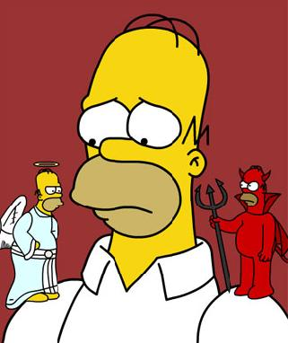

#6
THE ZONE OF PERSONAL GROWTH
Rabbi Eliyahu Dessler, Michtav M'Eliyahu
When two nations are engaged in warfare, and the war is fought on the battlefield, all the territory conquered by one particular army is now under its control, and the enemy has no foothold there whatsoever. Similarly, the territory of the second army comes totally under its control. If one of the armies conquers further ground and advances and takes over some of the enemy’s territory, then subsequent battles will resume with new battle lines. But territory which has already been conquered will not be fought over again, for it has already been occupied. There is only one battleground, and this can shift between the territories of the two warring nations.
The same is true of the nature of free choice. Each person has a zone of free choice where his conception of truth encounters his imagined truth – which is really falsehood. However, the majority of one’s actions occur where there is absolutely no conflict between truth and falsehood. Since a person has been educated to act in many areas in accordance with the truth, when he does so, he is not exercising his free will, since he has no option to do otherwise. Similarly, he might make incorrect decisions based on falsehood and not realize that these are improper actions. Since he is so accustomed to doing them, they are now beyond the range of his free will.

Decisions of free choice are limited to the meeting ground between the positive and negative forces within an individual. For example, many people might be negligent in speaking derogatorily about others, only because they are accustomed to it and are oblivious to its severity. The very same people however would never consider stealing or murder, because their education has ingrained in them not to do so, to the extent that they have no inclination to do such things.

The zone of free choice is dynamic. As a result of a good decision, a person raises his moral level, so that those areas which were previously the battleground between his positive and negative inclinations are now incorporated into the zone of his good side and will no longer present a conflict. This is the principle that “One mitzvah leads to another mitzvah” (Pirkei Avot 4:2).

The converse is also true. Bad decisions push away the tendency to behave properly in that battle zone and subsequently lead one to act improperly without deliberation, since his good side is no longer in control there. This is the principle that “One bad deed leads to another.”

Sometimes a person becomes accustomed to doing so much good that he is protected from the evil inclination in that area, and his zone of free choice is in more sublime areas. For instance, for a person who was educated in the ways of Torah, among righteous people, his zone of free choice will not be with regard to committing an actual sin or refraining from an actual mitzvah, but rather with regard to a very subtle point in his inner service of God and pure intent.

Sometimes a person is brought up in the company of evildoers, rabble and thieves. He will not have a choice at all regarding whether to steal or desist. It is possible that his zone of free choice will exist only when he is caught in the act of stealing, and he has the opportunity to murder someone. That is where the battle between his inclinations will take place, for that is the truth that his good inclination can discern at his level, and he could ignore his evil inclination.

#7 Question: What is your takeaway from today's discussion?

